Sarees Collection and Prices

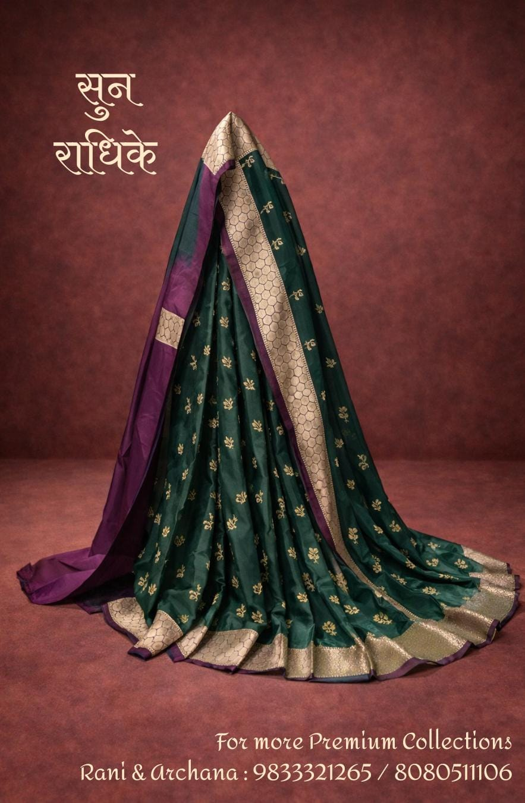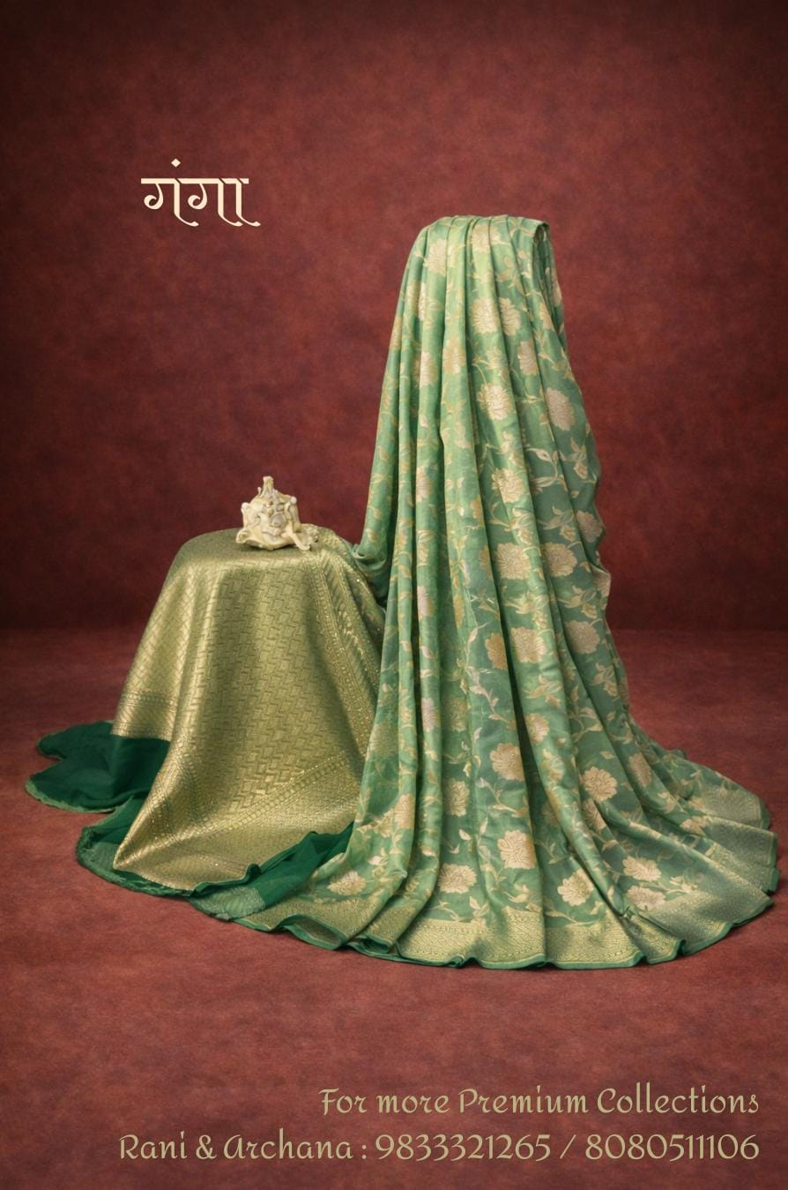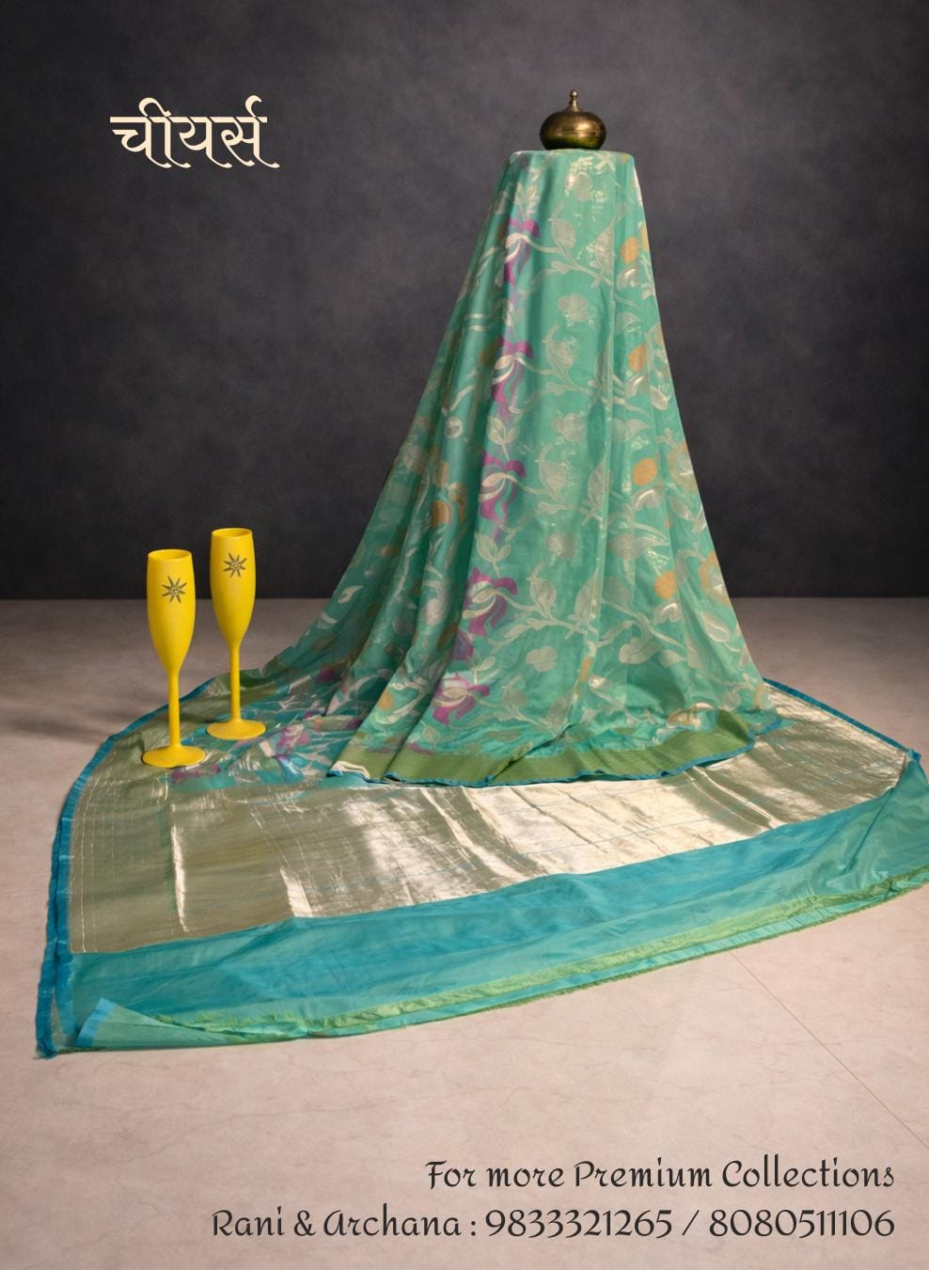
Name: Sun Radhike Name: Ganga Name: Chiyars
14,500 18,500 18,500

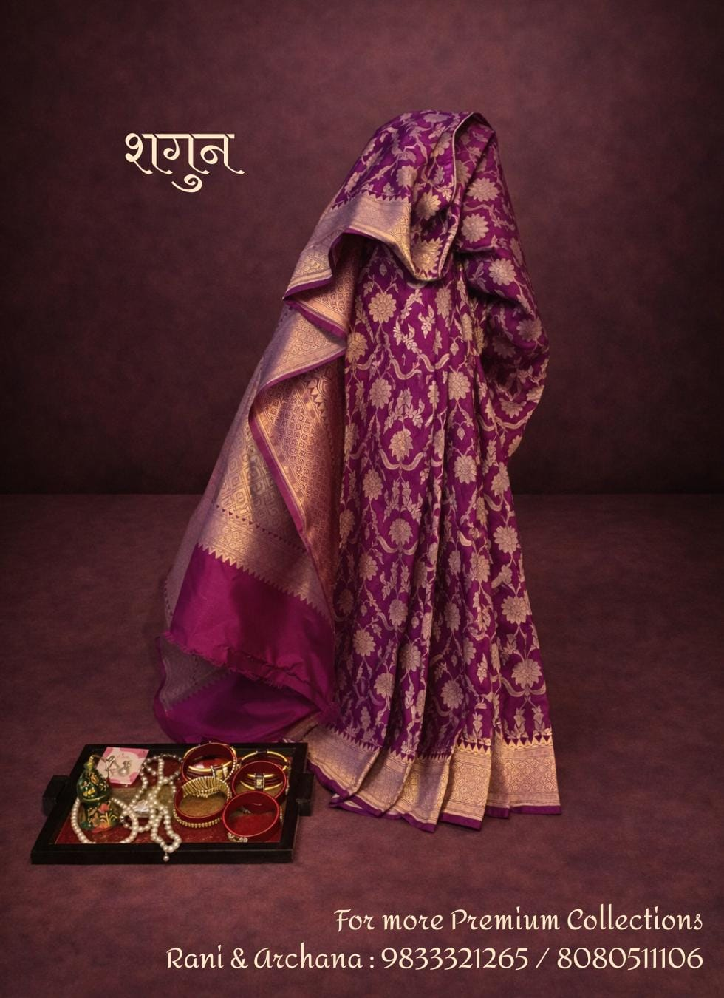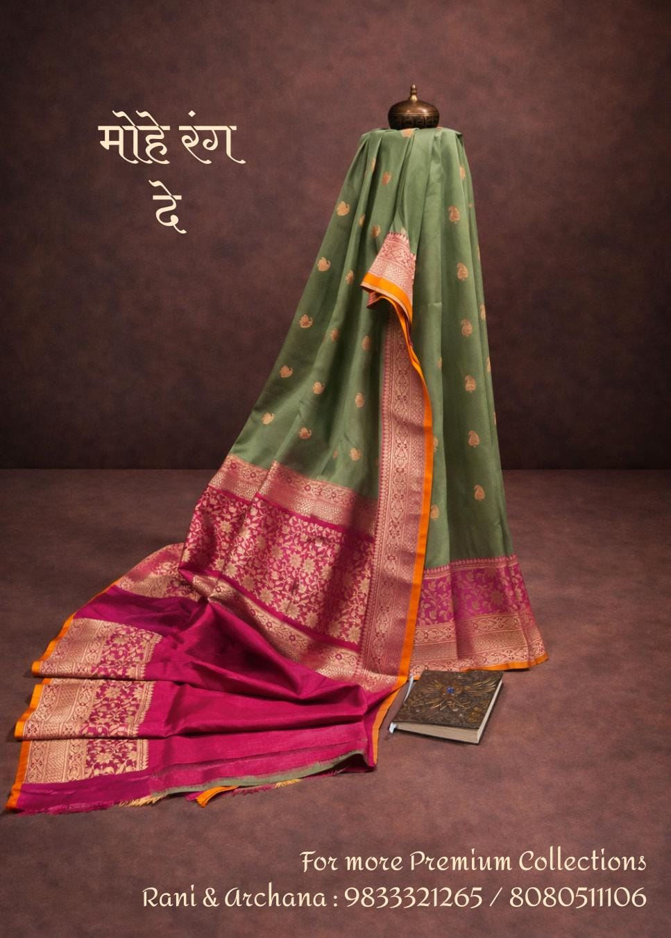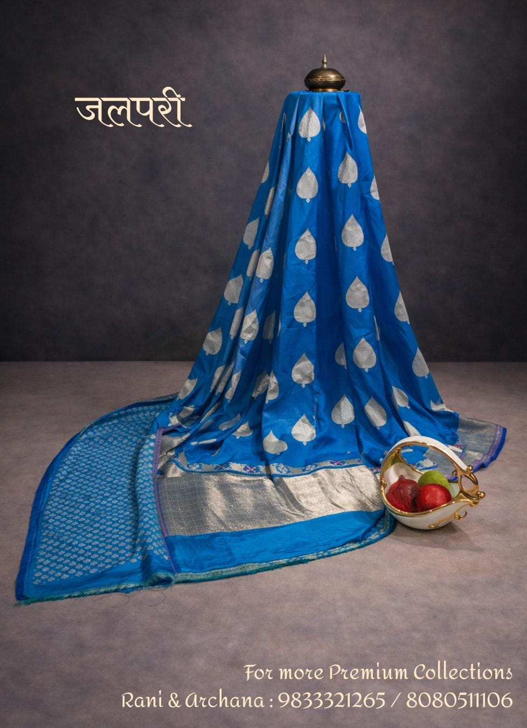
Name: Shagun Name: Moh Rang De Name: Jalpari
29,500 12,500 10,500

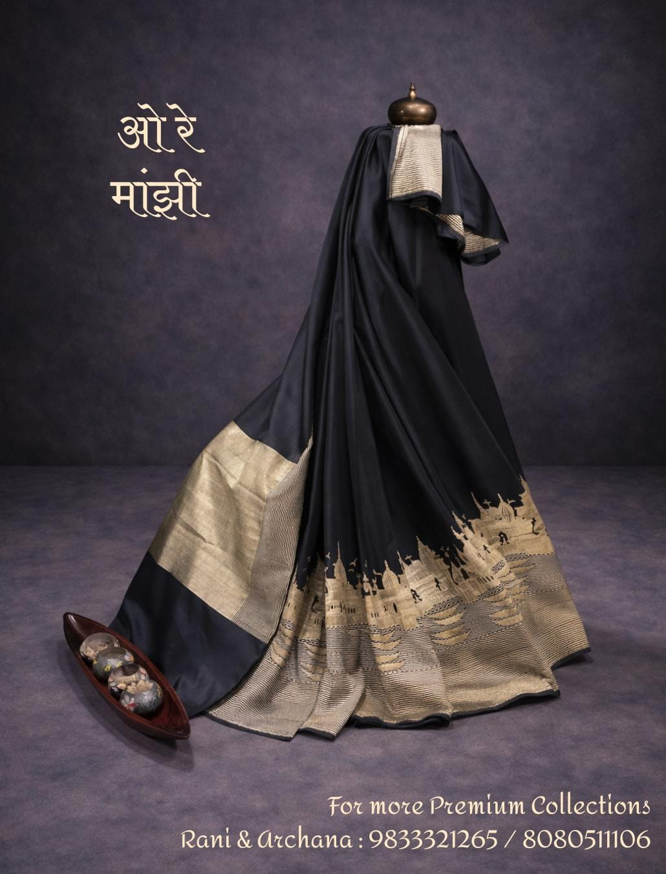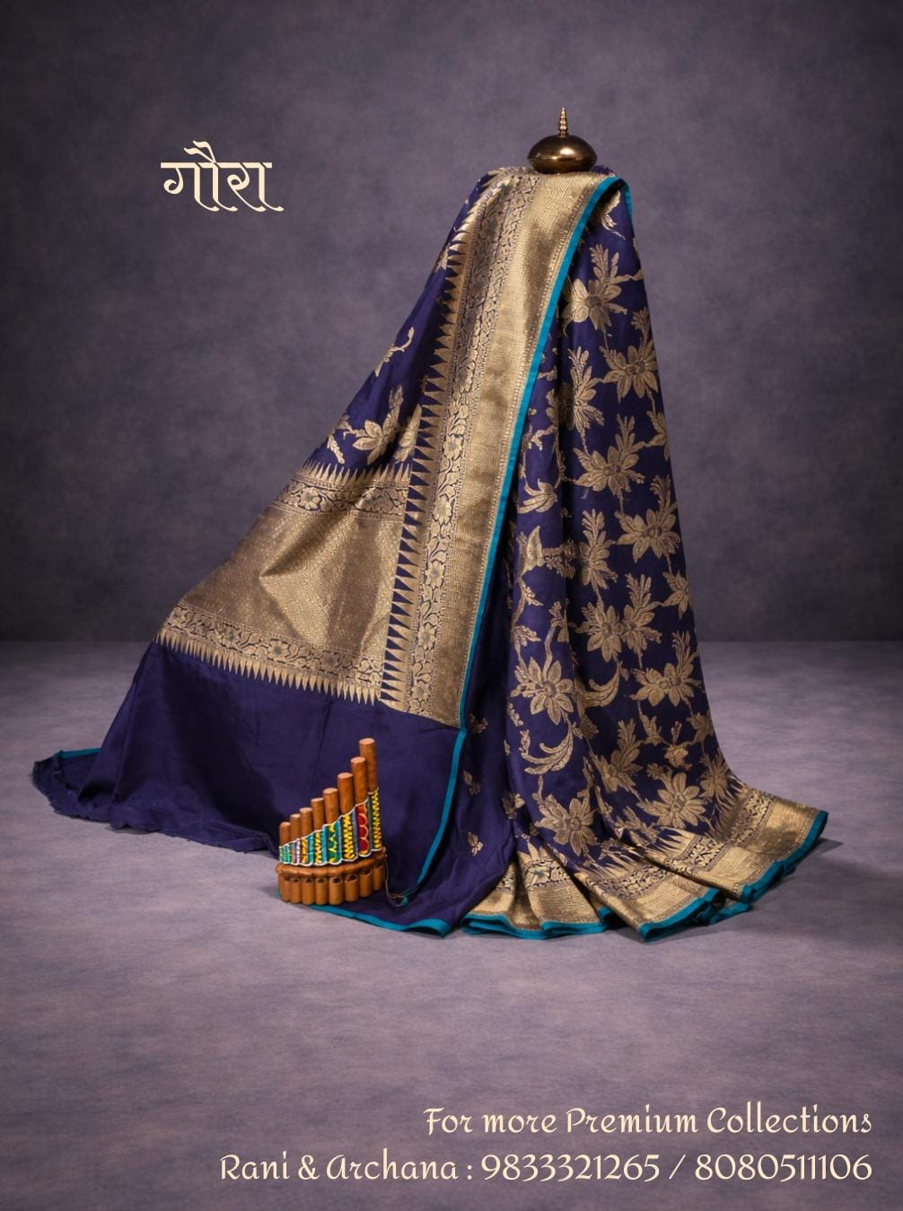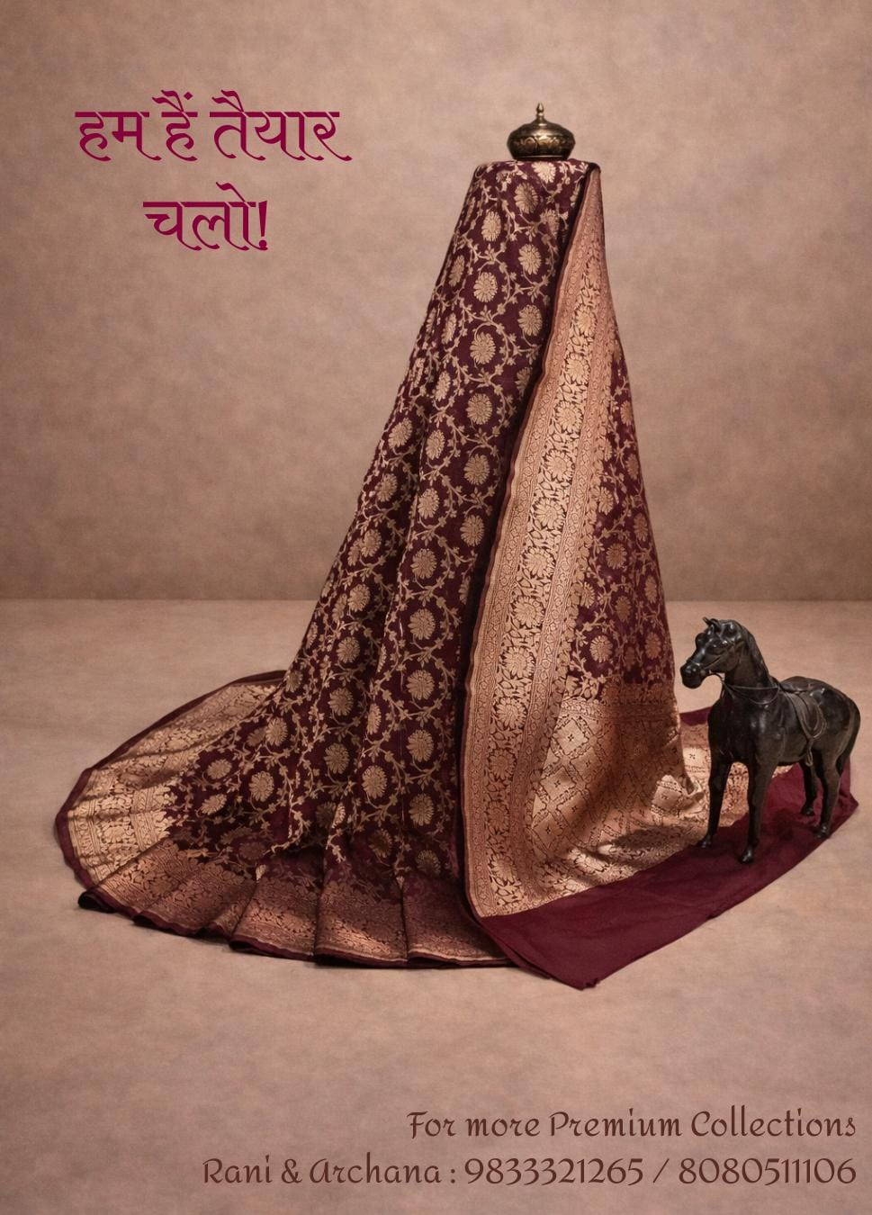 Name: Ore Manjhi Name: Gaura Name: Hum Hai Taiyar Chalo
15,500 10,500 29,500

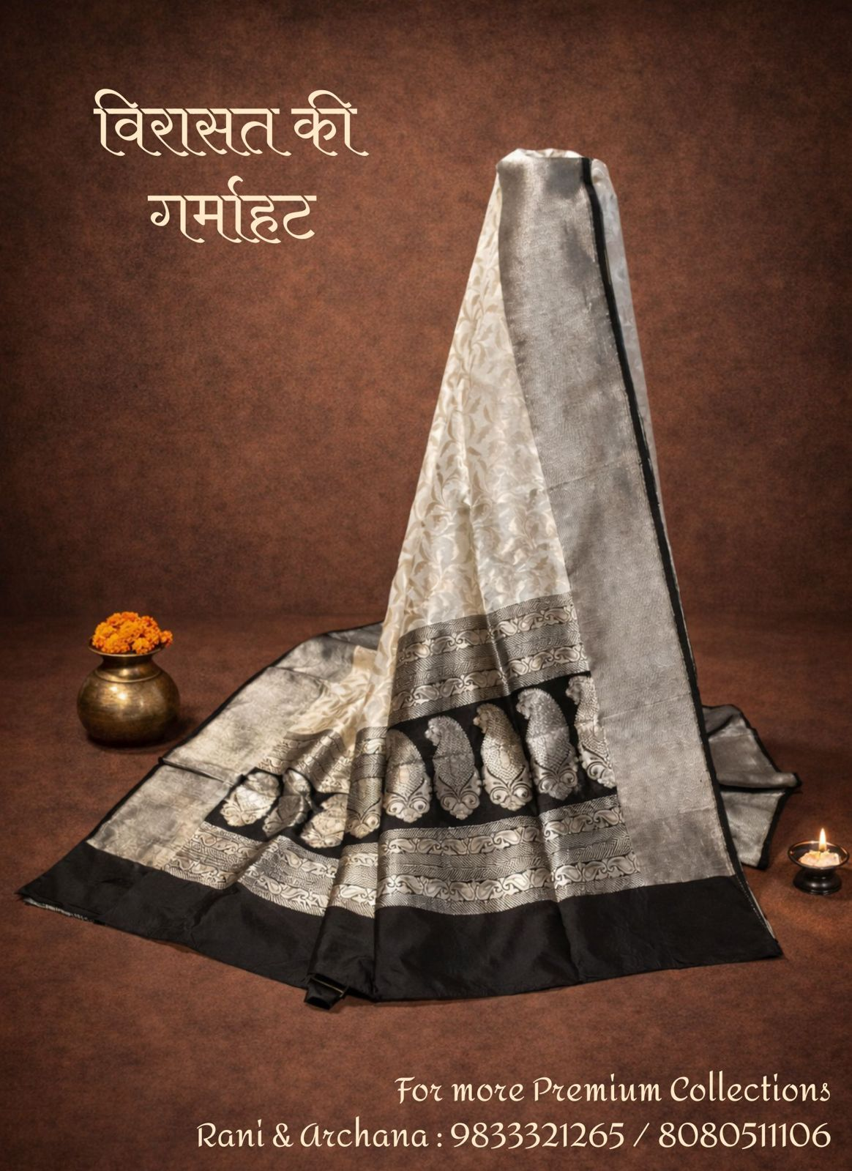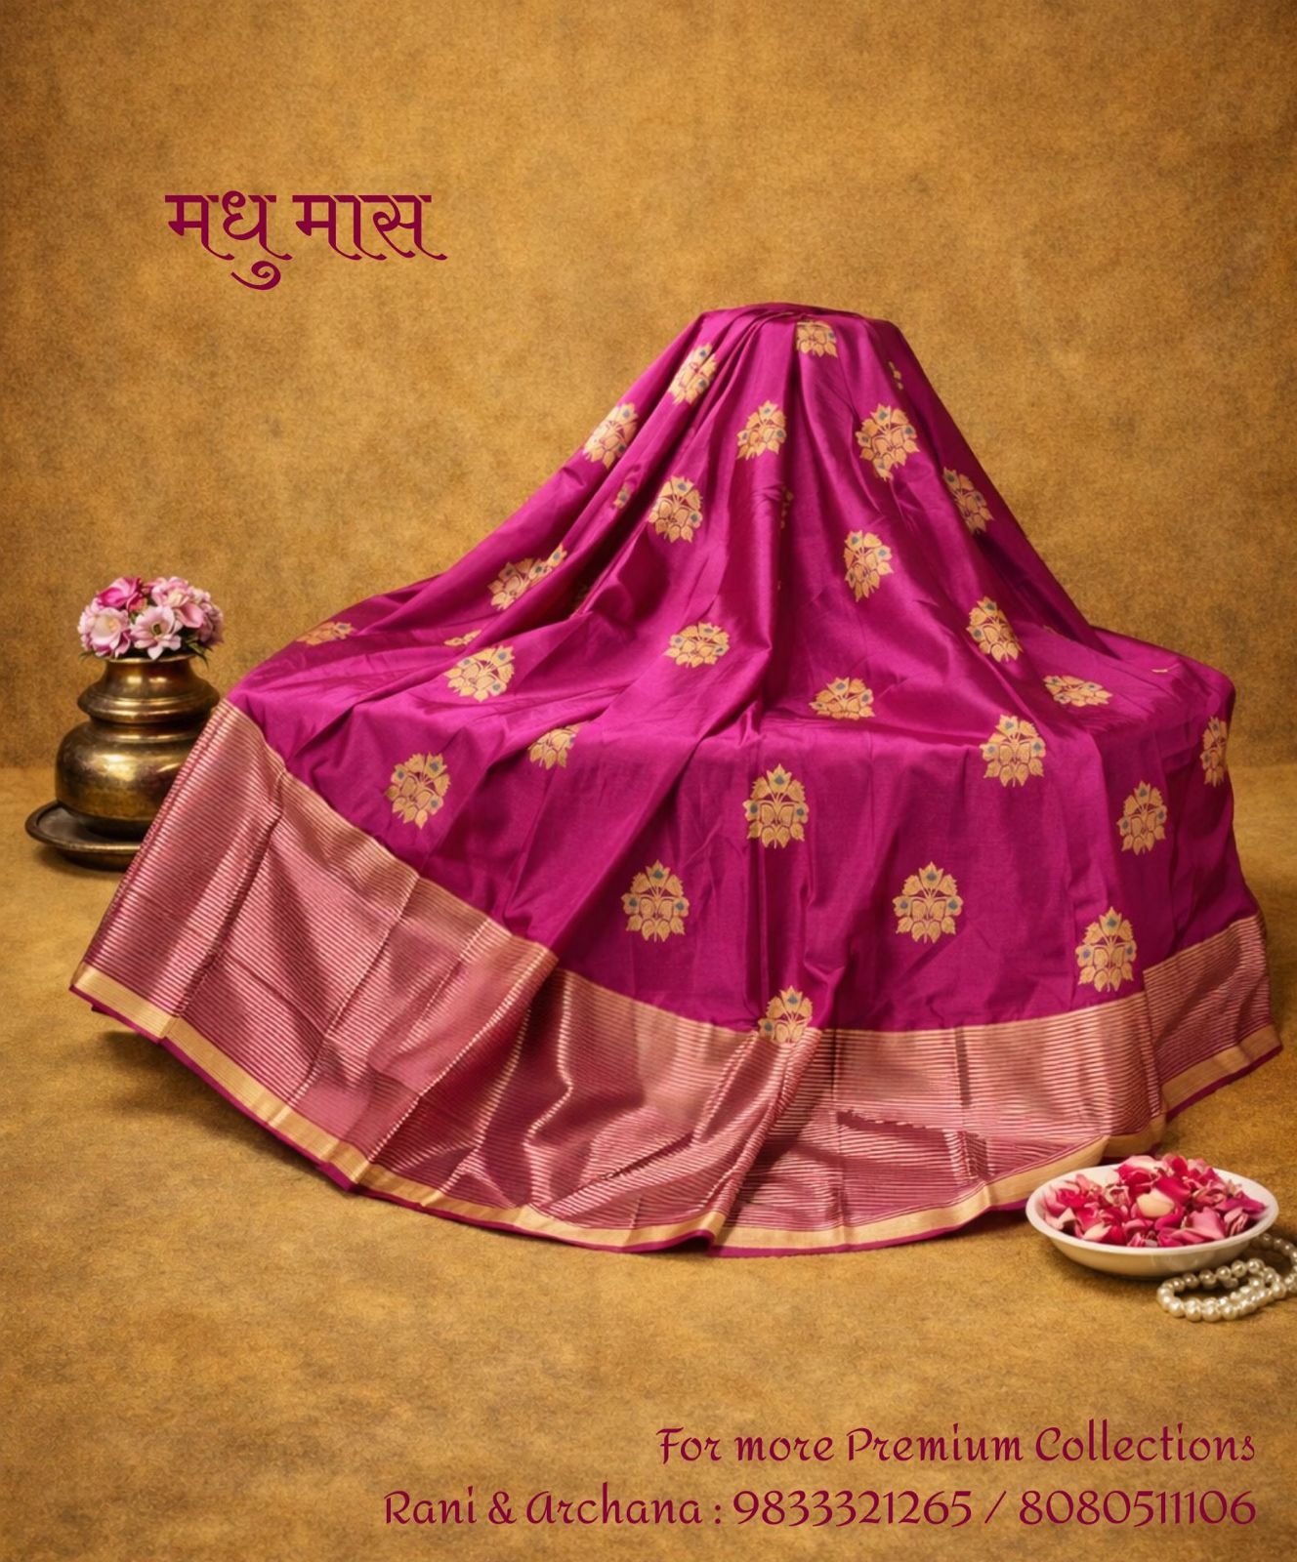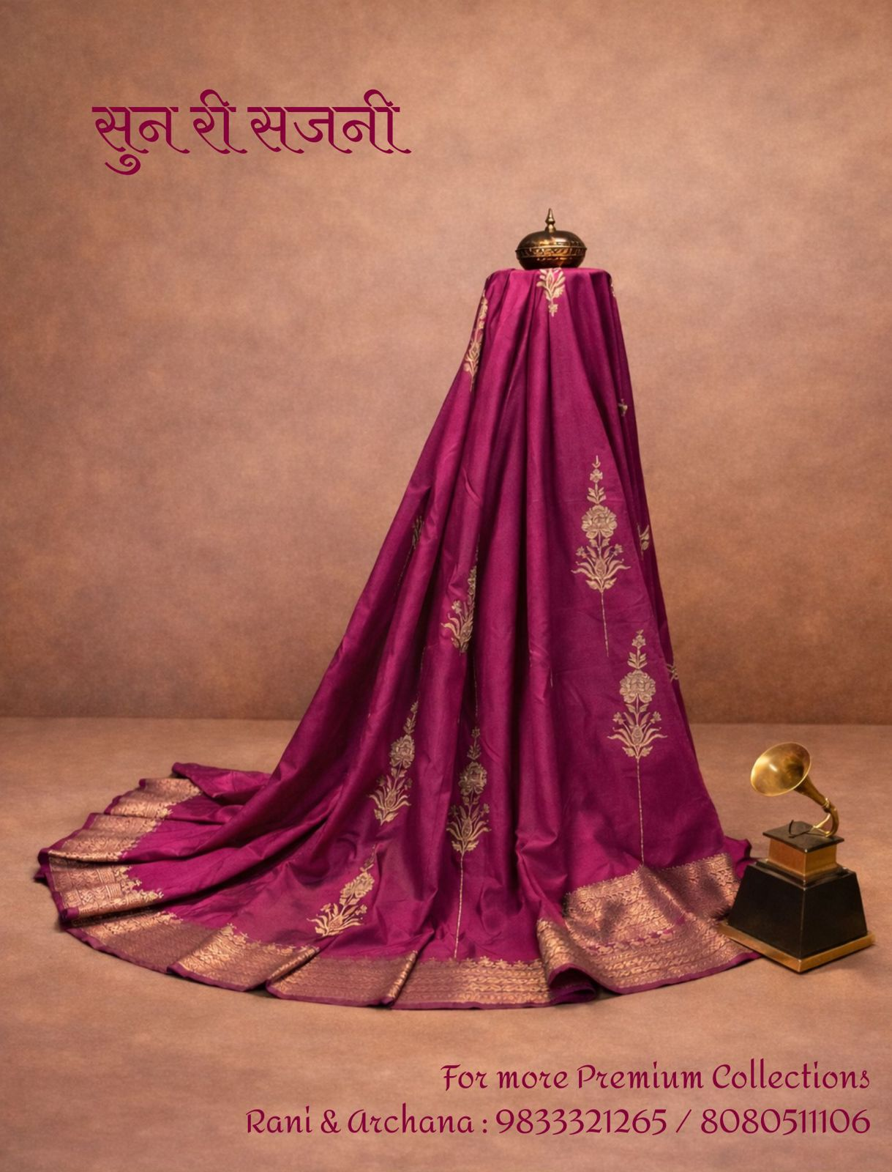
Name: Virasat Ki Garmahat Name: Madhu Maas Name: Sun Ri Sajani
25,000 16,500 16,500
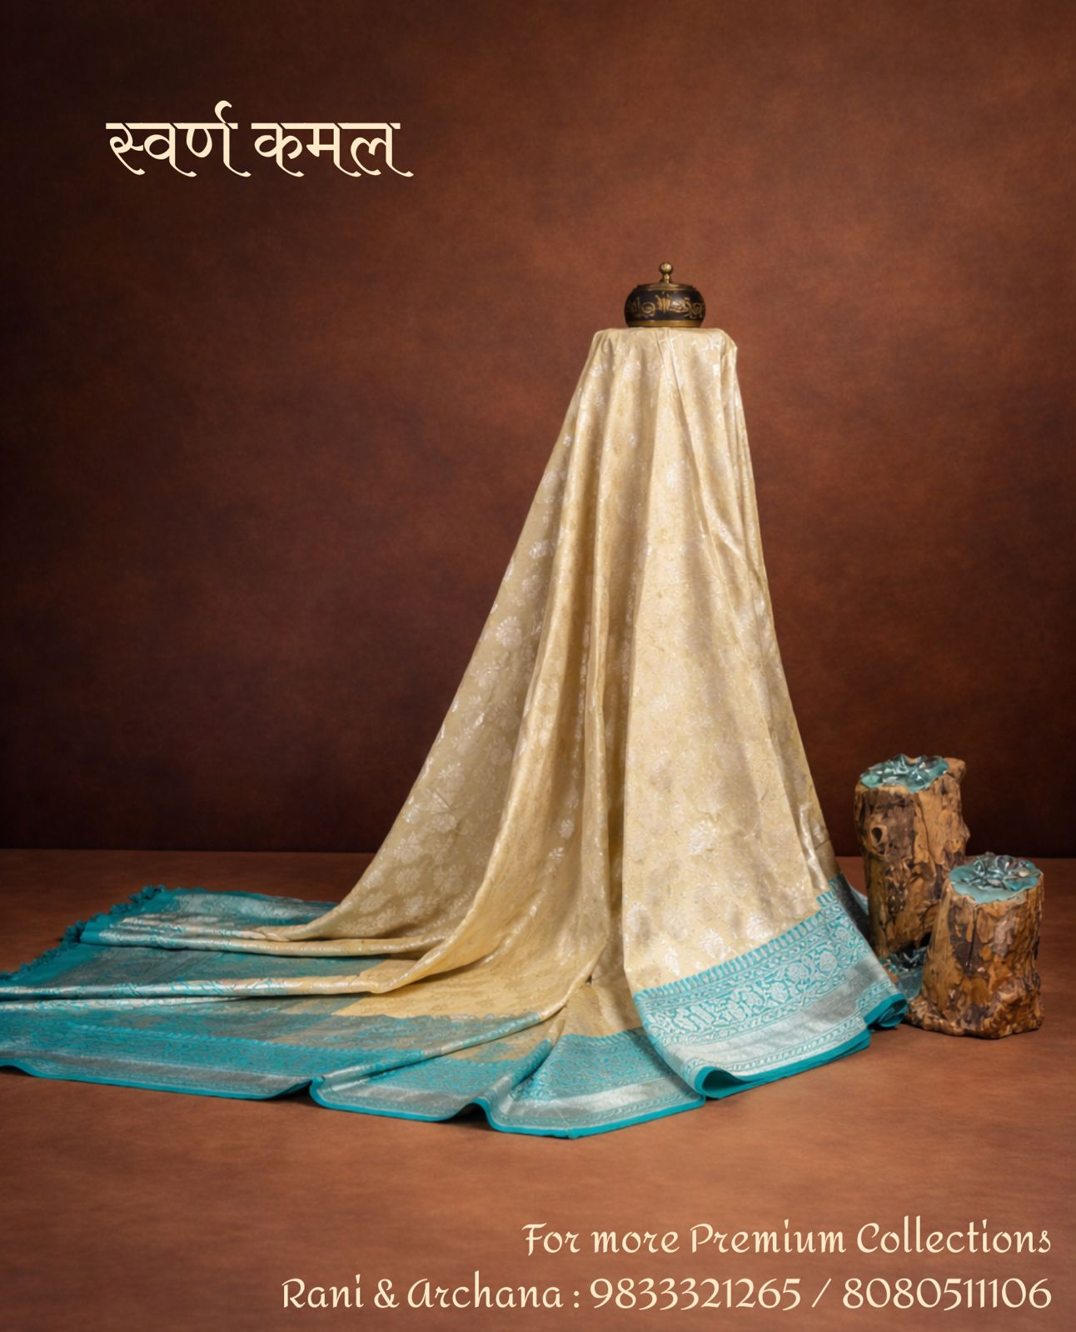
Name: Swarna Kamal
22,500

Reviews:

Mahalaxmi: Black is bold, Black is beautiful. And when it is Banarasi, it adds shine to the sun.
Authentic Banarasi silver zari to add the tinge of moonlight to a starry night in this saree.

